Sana’a
UNIVERSITY



FACULTY OF ENGINEERING

Mechatronics Department

Second Year

Report
Theorems

Supervision
Prof. Mohammed Al-Yadwmi
Eng. Mohamed Alhatary

Adopted by

Ibrahim Alkhlydy 202073007
Mechatronics (Parallel)
Group (3)

Table of Contents

Introduction............................................................................................................... ............. 1

Objecti........................................................................................................................................ 2

Methodology ...................................................................................................................... 3

Equipment........................................................................................................................... 4

Procedures........................................................................................................................... 5

Simulation........................................................................................................................... 6

Results.................................................................................................................................. 7
Table of values...................................................................................................................7

Discussion..................................................................................................... 8

References.............................................................................................................................................................. 9

Introduction:

The experience to learn what is the theorems and how we can make it and fro this experience we make a one voltage and three resistances to (complete the circuit. And also we use the potentiometer résistance to know the current

Objectives:

Measure how much the current and voltage move into some resistances at the theorems and read the measure in the (Multi meter) and how to make it

Methodology:

From this experience we can measure the current and voltage for some resistance in Same circuit with 9v in thermal circuit

Equipment:

Multimeter (DMM)

Tow batter (9V)

Some resistances.
Some wires.
Mother board
Potentiometer resentence

Procedures:

First: put the resistance in the mother board and measure without current
Second: connect one volt in the mother board after that connect the another volt.
Third: use one mlti meter to measure the current withe resistance with (volt1, volt2, and the both).

- Simulation
Part(1)
This simulation for measure the current
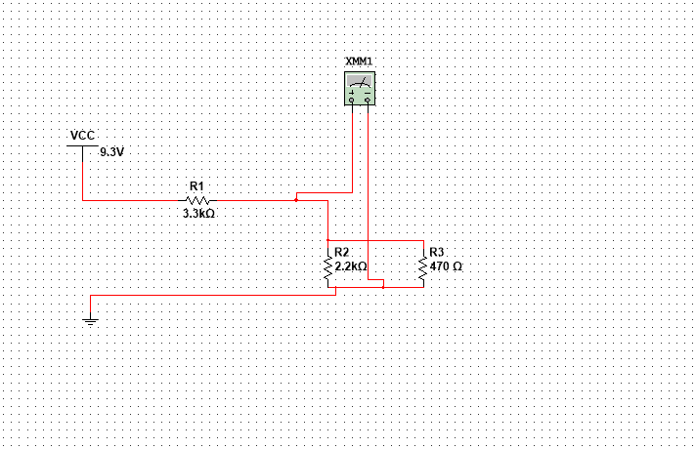

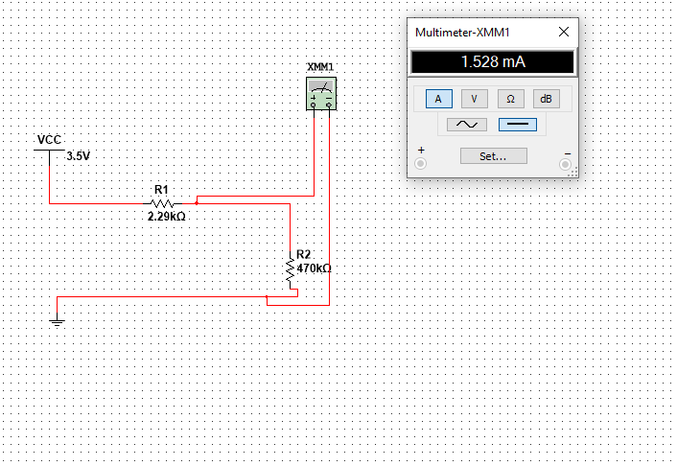

Part (2)
Potential

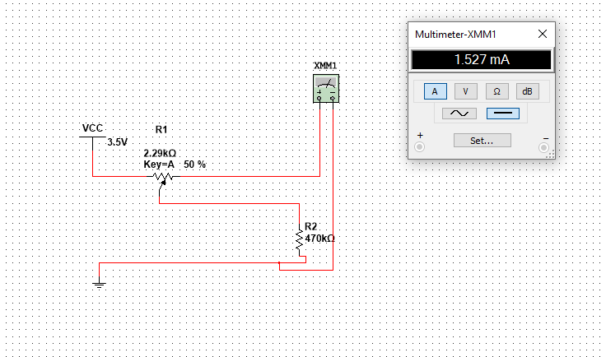
- Results:
Part (1)
R1=3.26kΩ
R2=2.17kΩ
R3=0.99kΩ
By calculate:Rth=2.32kΩ
Eth=3.5 v
Il=1.26mA

R=1470*2200/1470+2200=881.19Ω
881.19+3300=41.18kΩ=Rt=4.18kΩ
Is=9.3/4.8=2.22mA
I=IsR2/r2+R3//R4=2.21mA

Part(2)
Poteneial
Il=2.22(2.17/1.47+2.17)=1.32mA

- Discussion:

- We find some problem how to do it
- The second thing when we use the mutism
- When we change the potential r

- References:

Electronic Circuits by Boylestad.

